Basic Seismology Homework

1. Answer true or false

(a) The particle acceleration field reflection coefficient at the free surface has a positive polarity.
(b) Precritical plane-wave reflections can undergo a phase change.
(c) Particle velocity describes how fast a wavefront moves.
(d) The apparent velocity of a wave in a medium can be infinity.
(e) Dispersive waves have a velocity that is dependent on frequency and honor the relationship v=λf, where the independent parameters λ is wavelength and f is frequency.
(f) Plane wave post-critical reflections are usually weaker than the precritical reflections.
(g) Geometrical spreading represents permanent loss of elastic energy as a wave propagates.
(h) A low Q value in the rock means a highly attenuative medium.
(i) The displacement acceleration field reflection coefficient at the free surface has a negative polarity.
2. The diagram in Figure 1 represents a snapshot of an expanding spherical
wave. Answer the following questions and state your reasoning .
(a) What is the dominant source frequency?
(b) What is the apparent velocity along the 45 degree direction? The angle is measured with respect to the horizontal axis.
(c) What is the apparent wavelength along the 45 degree direction? The angle is measured with respect to the horizontal axis,
(d) What is the apparent wavelength along the 135 degree direction? What is the wavenumber vector k at point B?

Figure 1: Snapshot of an expanding spherical wave.
3. The harmonic pressure field for upgoing and downgoing plane waves is P=U+D, where U is the upgoing pressure plane wave and D is the downgoing plane wave. Derive the formula for the vertical particle velocity field V as a function of U and D. Now derive the formulas for U and D in terms of V and P.

4. Show that the traveltime t(x)=sqrt(x² + z² )/v₁ + sqrt((x_{r} – x)² + (z_{r} – z² )/v₂ is minimized when at x_{r} such that Snell’s law is satisfied sinα₁/v₁=sin α₁/v₂ . Here, Figure 2 shows that the source is at (0,0), the receivers are at (x_{r} , z_{r} ) and (x,z) is a point on the interface of the two-layer medium shown below. To find the x that minimizes t(x), simply take the derivative of t(x) w/r to x, and set it equal to zero. Solve dt/dx=0 for x and this is called the “stationary” point x* that minimizes t(x). This stationary point x* should also satisfy Snell’s law, which you should prove. Fermat’s principle says that the raypath between a source and receiver takes the path of stationary time, which in this case is the minimum time. Fermat’s principle leads to Snell’s law.
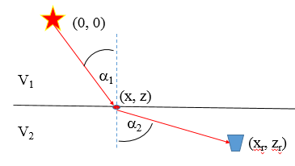

Figure 2.

